Artificial Intelligence (LAB)
Lab Task no.5

Submitted by:
Rana M. Moiz Safdar
Roll Number:
SU92-BSAIM-F25-209
Class/Section:
BSAI-3D
Submitted to:
Sir Rasikh ALi

Question 1. Minimax
Tree:
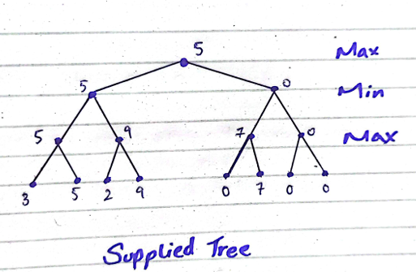

Working:
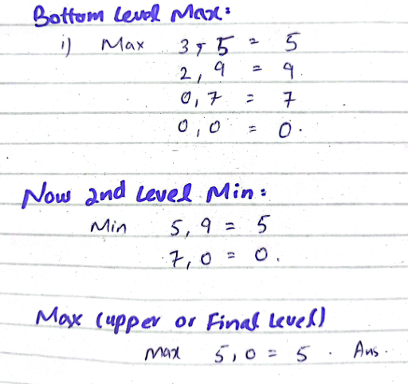

Explanation: Minimax is an algorithm. MAX selects highest value and Min selects lowest values. We start from bottom values also known as leaves and we calculate until we reach upward to final. In this tree we also used two 0 at the end of score because we wanted a complete binary tree and got finally value 5 as the result value.

Question 2. Leaf Evaluation Counter
Code: To add a leaf evaluator we added a variable named “counter” in the Lab given code in both algorithms. Initially it is at zero but every time a new leaf is reached the counter is given a +1 and this keeps up until the Goal is reached.
I also used same values for both algorithm to be fair and to see what the results under same condition are.
Result:
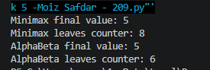
Explanation: Both Algorithm have the same final Value “5” but there leaves counter differ because Minimax goes through every single leaf node but whereas Alpha-Beta skip branches that won’t affect the output, So Alpha-Beta does fewer calculations and cut off unnecessary branches.
Tree:
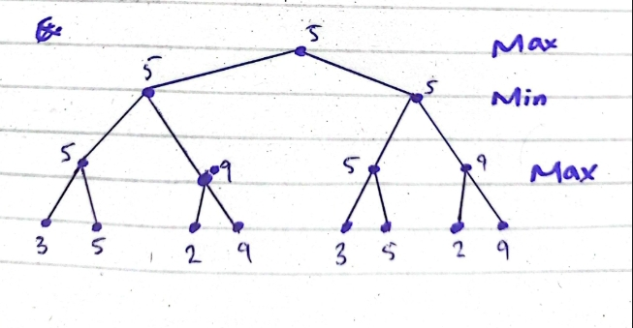

Question 3. Re-Order and check
Tree:
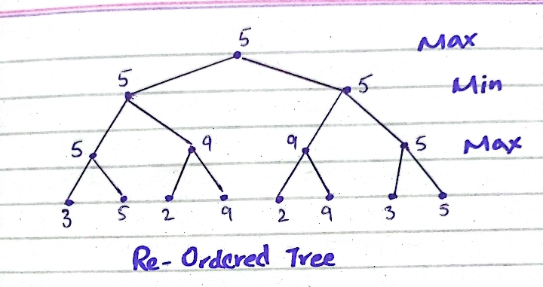

Result:
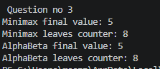
Explanation: after re-ordering the branches, Minimax still give the same results and evaluate all 8 leaves just like before. Alpha-beta pruning also evaluates 8 leaves this time instead of 6 because the new order didn’t allow any pruning. Where as in the original it pruned 2 off and gave result of 6. So order does matter in this algorithm but the final results will be the same.
Code: I used the same Code as Question 2 just changed the branch order and gave it to the parameter and solved the tree and gave answer accordingly.

